PROJECT PLANNING PHASE
Project Planning Template – Product Backlog, Sprint Planning, Stories & Story Points
Date | Not specified | Team ID | SWTID-2026-5003
Project Name | Implement Client Script & UI Policy (Incident) | Maximum Marks | 5 Marks

1. Product Backlog, Sprint Schedule, and Estimation
The backlog below maps the mandatory project tasks into epics, user stories, story points, and priorities.
Sprint | Functional Requirement (Epic) | User Story Number | User Story / Task | Story Points | Priority | Team Members
Sprint-1 | UI Policy Configuration | USN-1 | As an administrator, I can create the High Impact Control UI Policy on the Incident table. | 2 | High | Not specified
Sprint-1 | UI Policy Configuration | USN-2 | As an administrator, I can make Assignment group mandatory when Impact is 1 - High and reverse the rule when the condition is false. | 2 | High | Not specified
Sprint-1 | Urgency Control | USN-3 | As an administrator, I can configure the Urgency UI Policy Action as read-only for High Impact incidents. | 2 | High | Not specified
Sprint-1 | Urgency Control | USN-4 | As an administrator, I can verify that Urgency remains unchanged in visibility and becomes editable when the reverse condition applies. | 2 | Medium | Not specified
Sprint-2 | Client Script Automation | USN-5 | As an administrator, I can create an onChange Client Script on Impact for High Impact incidents. | 2 | High | Not specified
Sprint-2 | Client Script Automation | USN-6 | As a user, I can have Urgency automatically set to 1 - High when Impact is High. | 3 | High | Not specified
Sprint-2 | Save Validation | USN-7 | As an administrator, I can create an onSubmit Client Script to validate Assigned To before saving a High Impact incident. | 2 | High | Not specified
Sprint-2 | Save Validation | USN-8 | As a user, I cannot save a High Impact incident when Assigned To is empty. | 3 | High | Not specified
Sprint-2 | List Editing Control | USN-9 | As an administrator, I can create an onCellEdit Client Script for the State field. | 2 | Medium | Not specified
Sprint-2 | List Editing Control | USN-10 | As a user, I cannot change State through direct list editing, while form-based State updates remain allowed. | 3 | High | Not specified
Sprint-3 | Testing & Verification | USN-11 | As a tester, I can verify mandatory enforcement for High Impact incidents. | 2 | High | Not specified
Sprint-3 | Testing & Verification | USN-12 | As a tester, I can verify successful save when Assigned To is populated and confirm the expected controls. | 2 | High | Not specified
Sprint-3 | Testing & Verification | USN-13 | As a tester, I can verify that changing Impact from High to Medium reverses the mandatory/read-only behavior. | 2 | Medium | Not specified
Sprint-3 | Testing & Verification | USN-14 | As a tester, I can verify that direct State list editing is blocked. | 2 | High | Not specified
Sprint-3 | Testing & Verification | USN-15 | As a tester, I can verify that State can still be changed through the Incident form. | 2 | Medium | Not specified

2. Project Tracker, Velocity & Burndown Chart
Sprint | Total Story Points | Duration | Sprint Start Date | Sprint End Date (Planned) | Story Points Completed (as on Planned End Date) | Sprint Release Date (Actual)
Sprint-1 | 8 | Not specified | Not specified | Not specified | Not specified | Not specified
Sprint-2 | 15 | Not specified | Not specified | Not specified | Not specified | Not specified
Sprint-3 | 10 | Not specified | Not specified | Not specified | Not specified | Not specified

Total planned story points: 33
Planned average velocity: 11.00 story points per sprint (based on 3 planned sprints).
Actual velocity: Cannot be determined until completed story points are recorded.
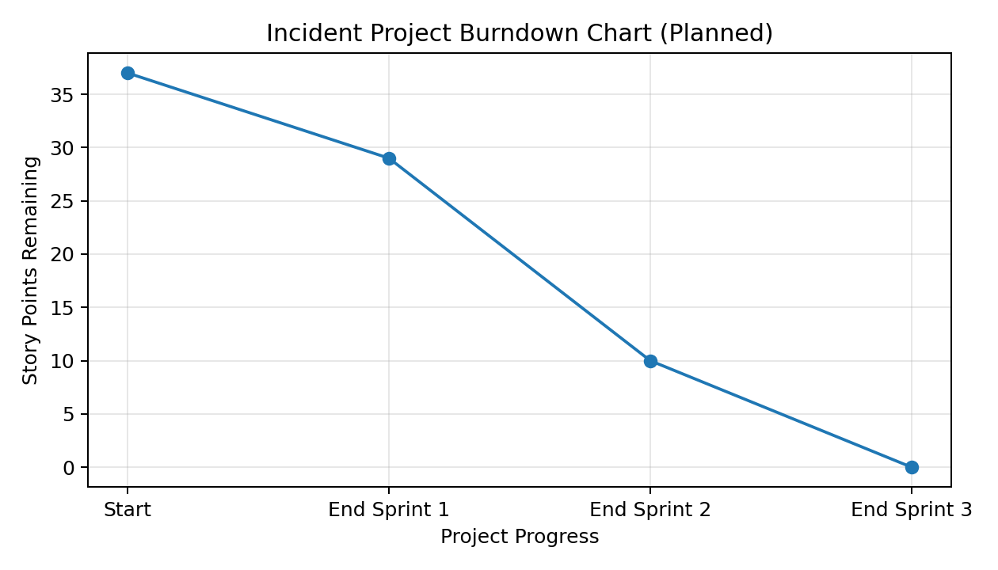
Figure: Planned burndown of the 33 story points across the three planned sprints.
Note: The template asks for actual completion and release dates. These values are left as 'Not specified' because the supplied project source does not provide actual sprint dates or completed-point data.

